Tableau Day 1 - Exercises

Exercise 1

For each of the following data visualizations, identify the relevant **chart type** and the **data type(s)** from the following bank of options.

|  |  |
| --- | --- |
| **Chart type** | **Data type** |
| Bar chart  Line chart  Area chart  Heatmap  Scatterplot  Histogram  Map | Univariate data  Bivariate data  Multivariate data  Trend data  Text data  Geospatial data |

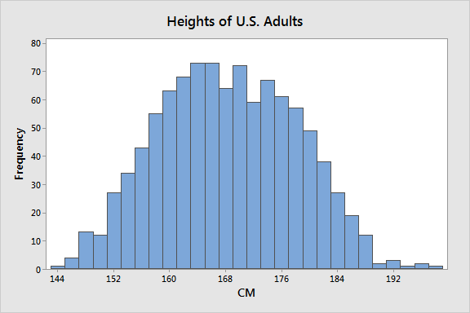

Answer:

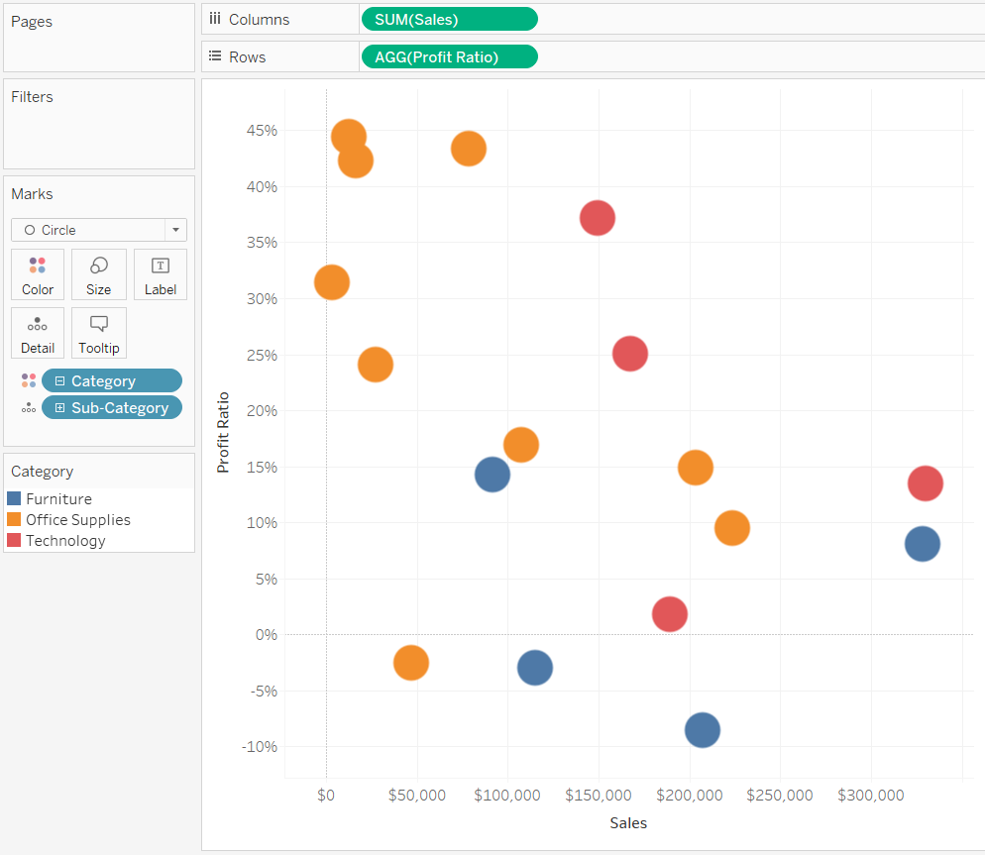

Answer:

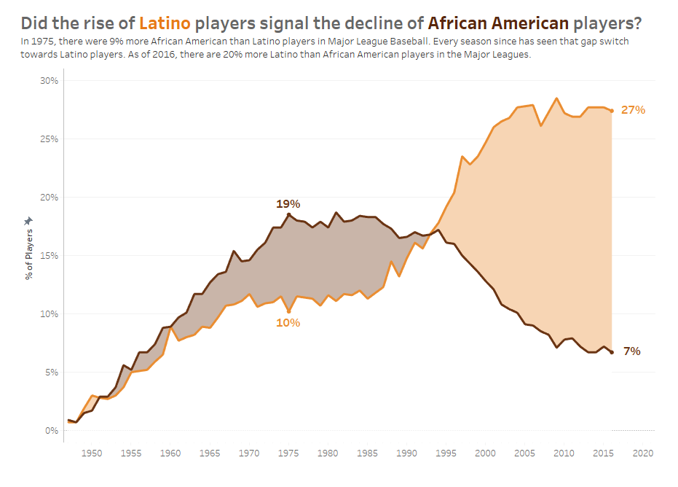

Answer:

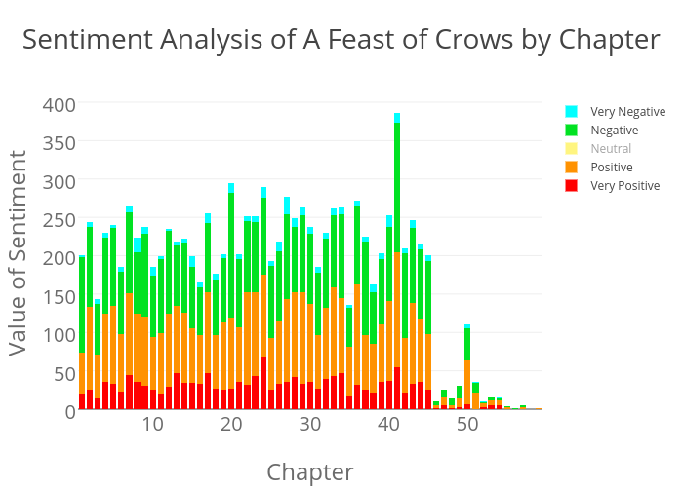

Answer:

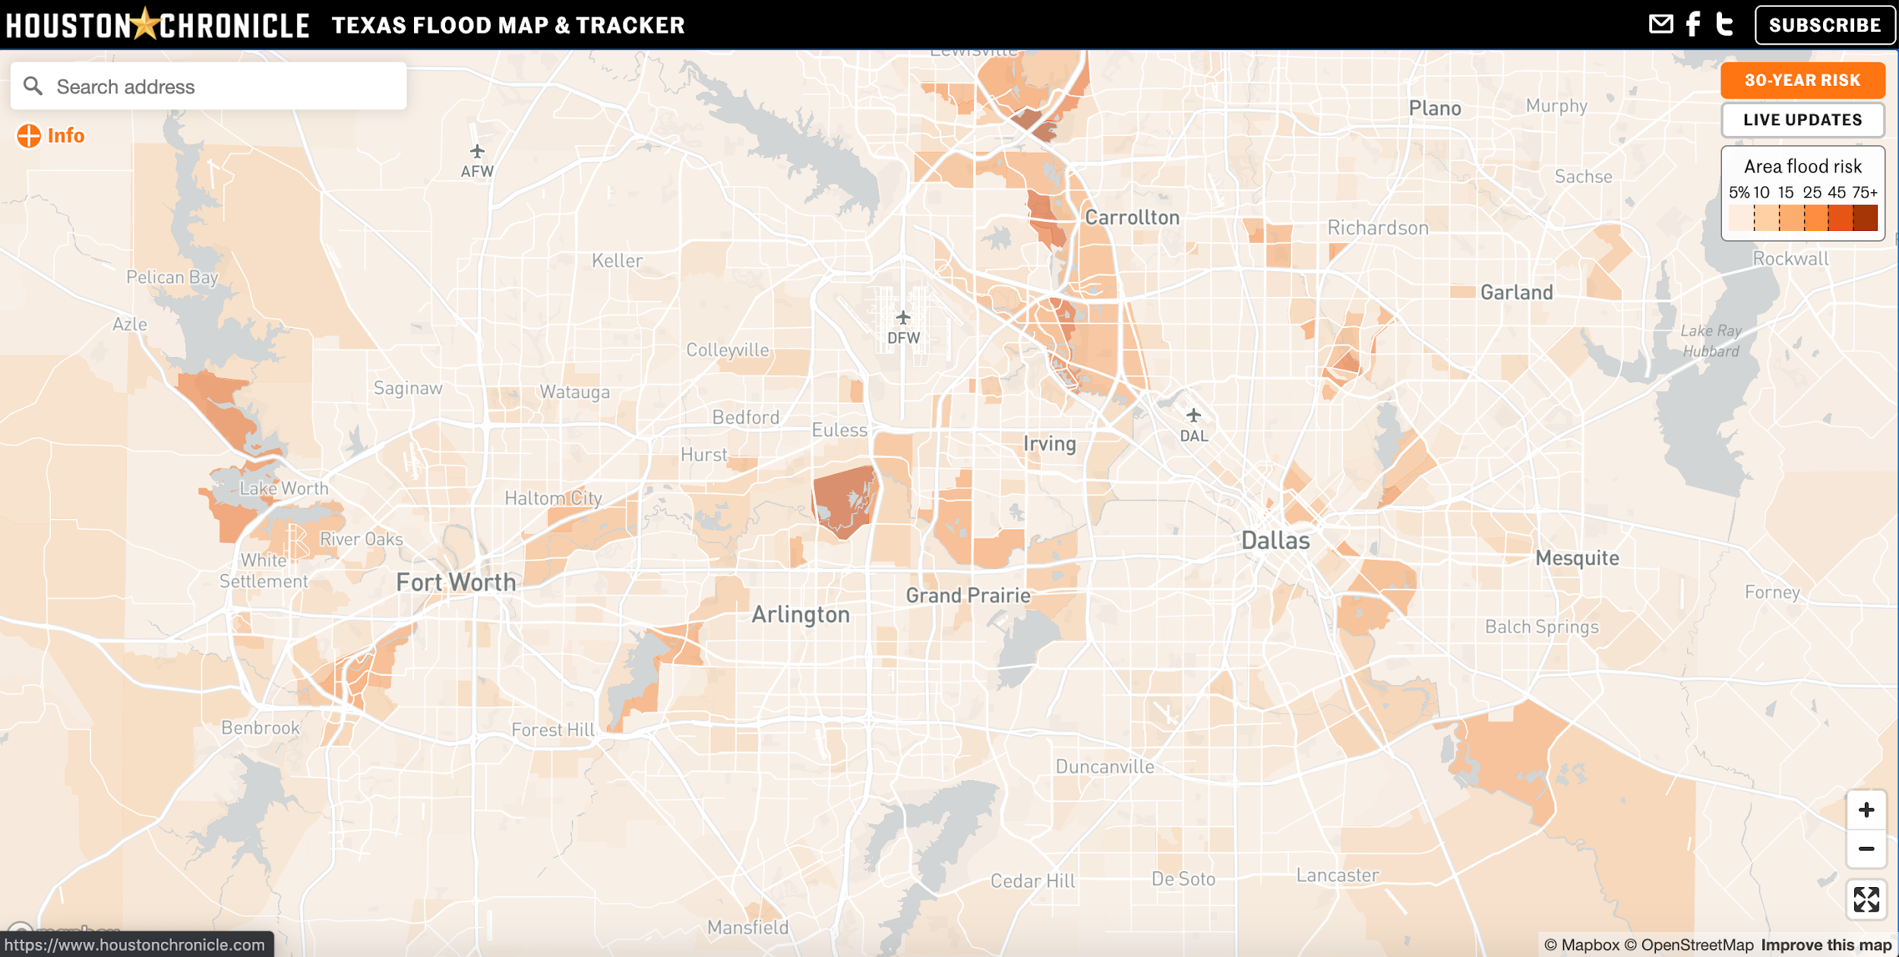

Answer:

Exercise 2

1. Consider the following (confusing) chart:

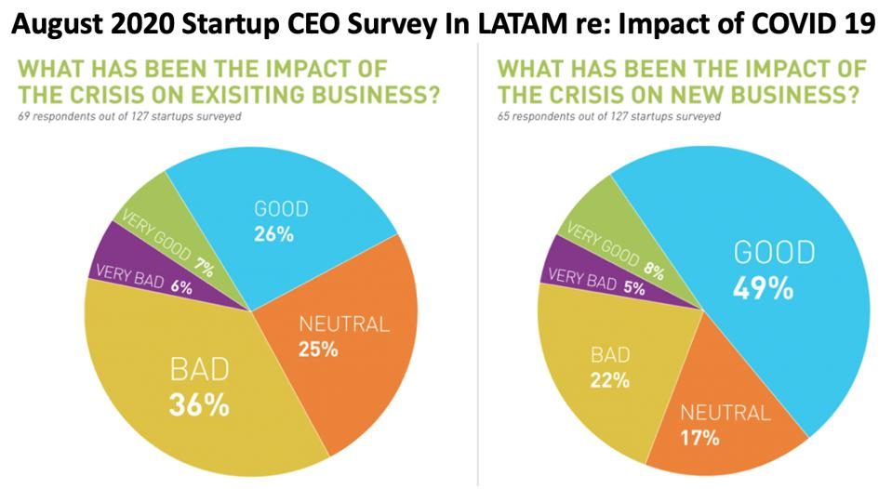

Setting aside its other problems, how might you use **color** to re-encode this data differently? Would you use a **sequential, diverging, or categorical** color scheme? Why?

Answer:

1. Consider the following (confusing) chart:

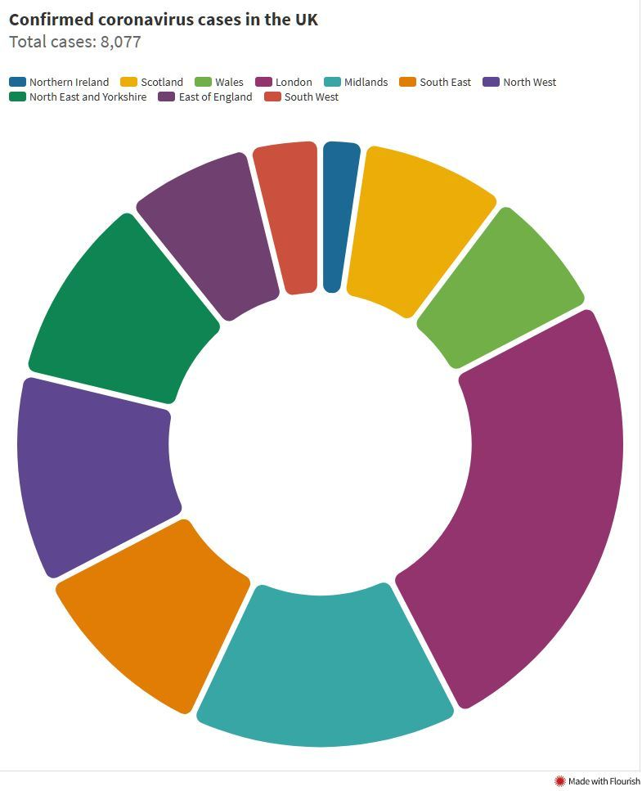

Setting aside its other problems, how might you use **position, labels, and color** to make this chart more easily interpretable? Is there any additional data you might like to add or represent in some way?

Answer:

1. Consider the following (confusing) chart:

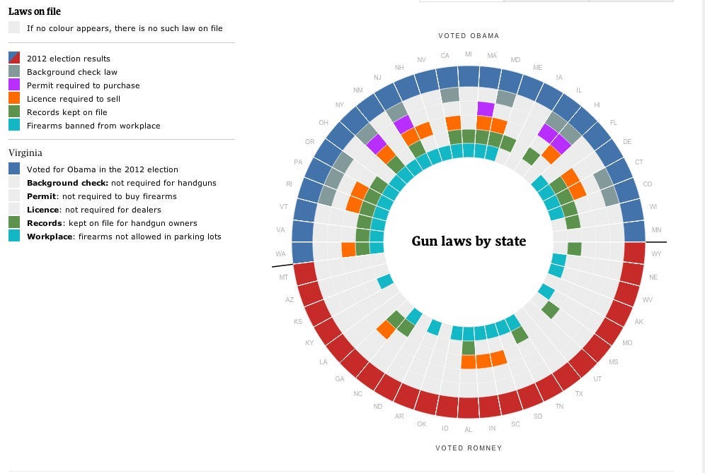

What might you change about how the data has been represented to make it easier to interpret? Consider the basic building blocks of visual design: **size, shape, position, labels / legends, and color**.

Answer: